I
N
F
O

R
M
A
T
I
O
N

P
A
C

K

MENAI AA & B GRADE SHORT COURSE MEET (Under World Aquatics Technical Rules & Swim Wales Laws)

This event is licensed at Level 3 by Swim Wales

Meet License No pending

Sunday 8th March 2026

Closing date for entries is the 12th February 2026.

Age groups: 8, 9, 10, 11, 12, 13, 14+, age on day of meet.

VENUE:
Canolfan Nofio Llandudno Swimming Centre

Mostyn Broadway

Llandudno

Conwy

LL30 1YR

General Information
This gala is an AA and B Grade Meet. Swimmers will be graded based on times swum on the day, not on entry times.

The AA Grade is the Upper Limit Time for entries, but there is no lower entry time limit, so swimmers with no times are eligible to enter.

No entries will be accepted that are faster than the AA cut-off times. Age is on the day and competitors will not be allowed to swim out of age. The Age Groups are 8, 9, 10, 11, 12, 13 and 14 & over.

Entries will be restricted in over-subscribed events and the organisers reserve the right to alter any part of the programme.

Closing date for entries is the 12th February 2026. Entrant numbers must be finalised on this date if maximum capacity not already reached. Please email entries to swimgwyneddgala@gmail.com
It would help us if you are able to send your entries electronically on the Hy-Tek system.

Entry fee is £7.00 per event. Relays £20 per team entry.

Relays
To enable more clubs to compete in the relays, we will allow any combination of 4 swimmers (4 girls/4 boys/mixed boys & girls) but they will all compete against each other and medals will be awarded to the top 3 teams regardless of combination. Relay times will NOT count for rankings. If we are inundated with entries we may have to limit clubs to 1 team per age group but please submit as many as you want and we will confirm entries.

Payments to be made by BACS transfer to Nofio Gwynedd Performance
Sort code: 51 61 28
Account Number: 11358432
Please state your club name as reference

Events
Length of Pool - 25 metres, 8 lanes, with anti-turbulence lane ropes and good spectator viewing area.
- All events will be held under World Aquatics Technical Rules & Swim Wales Laws.
- Electronic timing will be used with manual timing in event of breakdown. Times and positions shown on the scoreboard are for information only, they are not necessarily the official result.
- All events HDW.
- There will be no cards at this gala. Withdrawal slips will be available.
- The referee’s decision will be final on all matters relating to swimming and swimmer discipline.

Medals are awarded to the top 3 in each age group in each event who do not exceed the cut-off times. Speeding bands will be awarded to swimmers who swim faster than the AA Grade cut-off times.

Poolside Access
Poolside access will be restricted to competitors, officials and coaches with passes. There are strict fire regulations with regard to the number of people allowed on poolside, and lifeguards must be able to patrol their area unhindered. Only swimmers actually swimming in the event will be allowed on poolside.

Poolside pass £10.00, limited to 1 pass per 10 swimmers. All personnel applying for a poolside pass must have an up to date DBS. 1 free poolside pass for every official provided for at least 2 sessions.

Officials
To allow us to run this licensed meet, all clubs will need to provide at least one official in every session. Our requirements are one official if the club has 1-10 swimmers competing and two for 10+ swimmers. Please ask officials to sign up via swim meet (https://swim-meet.com/)

Spectators
Spectator entry fee applies per session. All day passes are also available. There are 3 sessions.
The Swimming Centre is situated next to a Council Car Park.
The organisers will not accept responsibility for any loss of belongings.

HEALTH & SAFETY

- The health, safety and wellbeing of all swimmers, officials, volunteers, spectators and visitors is paramount – all Health and Safety rules / regulations/ requirements must be complied with at all times.

- A full risk assessment must be carried out in accordance with the Swim Wales Meet License Report Pack. A copy of the Pool Operating Procedures and / or the Normal Operating Procedures & Emergency Action Plan for the facility being hired for a meet must be obtained in advance, and must be available throughout the duration of meet.

- All swimmers, officials, volunteers, spectators, and visitors are required, at all times, to abide by the rules set out in the Pool Operating Procedures and / or the Normal Operating Procedures & Emergency Action Plan for the facility hired for the meet.

- Unacceptable Behavior will not be tolerated. Behaviour becomes “unacceptable” when it is considered “Offensive” to others; this includes, but is not limited to, the following:

- Theft, wilful damage to property and / or equipment, acts of vandalism, abuse of alcohol and / or drugs, bullying, offensive language, aggressive / violent acts, threatening behaviour, all breaches of safety practices, failure to comply with instructions / directions, actions that bring the sport of swimming into disrepute.

- Swimmers must have attained the standard of the Competitive Start Award in order to start from the blocks; (this is the responsibility of the club coach). Swimmers who have not attained the standard of the Competitive Start Award must lower themselves into over the side into the water, on the long whistle of the Referee before starting at an appropriate place.

- Jewellery: For safety and security reasons, the wearing of jewellery is not permitted while in the water during warm-ups / swim-downs and / or competition. This includes watches, necklaces, chains, bangles, wrist bands, ear-rings (except studs), and rings (except wedding bands). Swim Gwynedd will not be responsible for any jewellery brought to events and will not be liable if such jewellery is lost or damaged.

- Video and Photography: When a competition involves children under the age of 18 years of age it is a mandatory meet license requirement that all persons (including competitors / officials / volunteers / spectators), wishing to engage in any kind of photographic activity including video, zoom, close range photography, irrespective of the nature of the device / equipment used for taking / recording such images must register their details with the event management in advance of taking any images. However, there is a policy that no photography of any kind – cameras, videos or phones – takes place inside the building.

Any conditions not covered in this information pack will be at the discretion of the promoters.

Age Groups: 8, 9, 10, 11, 12, 13 & 14/o - Age on day

Session 1

Event | Age Group | Distance | Stroke
1 | Girls 8 & over | 100m | Freestyle
2 | Boys 8 & over | 100m | Butterfly
3 | Girls 8 & over | 50m | Breaststroke
4 | Boys 8 & over | 50m | Backstroke
5 | Girls 8 & over | 100m | Backstroke
6 | Boys 8 & over | 100m | Freestyle
7 | Girls 8 & over | 50m | Butterfly
8 | Boys 8 & over | 200m | Individual Medley

Session 2

Event | Age Group | Distance | Stroke
9 | Girls 8 & over | 200m | Individual Medley
10 | Boys 8 & over | 100m | Backstroke
11 | Girls 8 & over | 50m | Freestyle
12 | Boys 8 & over | 50m | Freestyle
13 | Girls 8 & over | 100m | Butterfly
14 | Boys 8 & over | 100m | Breaststroke
15 | Mixed 8-10 years | 200m | Medley Relay (4x50m)
16 | Mixed 11-13 years | 200m | Medley Relay (4x50m)
17 | Mixed 14+ years | 200m | Medley Relay (4x50m)

Session 3

Event | Age Group | Distance | Stroke
18 | Boys 8 & over | 50m | Breaststroke
19 | Girls 8 & over | 100m | Breaststroke
20 | Boys 8 & over | 50m | Butterfly
21 | Girls 8 & over | 50m | Backstroke
22 | Mixed 8-10 years | 200m | Freestyle Relay (4x50m)
23 | Mixed 11-13 years | 200m | Freestyle Relay (4x50m)
24 | Mixed 14+ years | 200m | Freestyle Relay (4x50m)

Girls Upper Limit AA Grade Qualifying Times

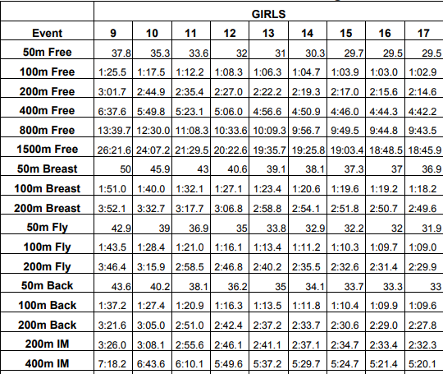

Boys Upper Limit AA Grade Qualifying Times

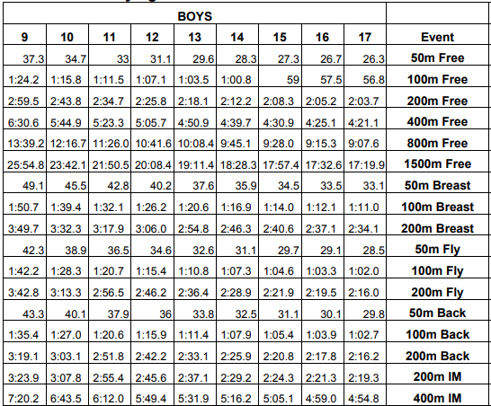

Girls Upper Limit B Grade Qualifying Times

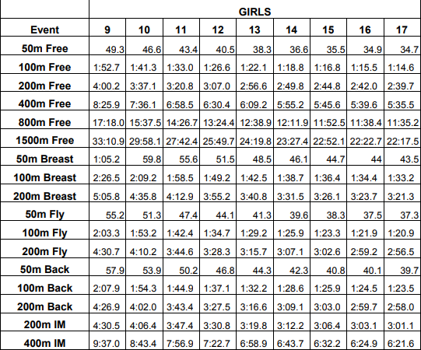

Boys Upper Limit B Grade Qualifying times

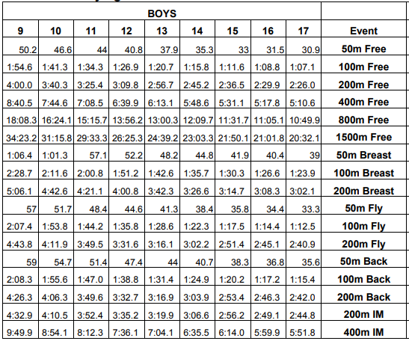

Menai AA&B 8 year old times

Race | Girls AA | Girls B | Boys AA | Boys B
50 free | 41.3 | 52.0 | 40.8 | 52.0
100 free | 1:35.5 | 1:59.1 | 1:34.2 | 1:59.0
50 back | 48.1 | 1:00.1 | 47.8 | 1:00.3
100 back | 1:49.2 | 2:14.9 | 1:47.4 | 2:14.2
50 breast | 55.0 | 1:08.4 | 54.1 | 1:08.1
100 breast | 2:04.7 | 2:31.0 | 2:04.4 | 2:32.0
50 fly | 47.9 | 59.3 | 47.3 | 59.4
100 fly | 2:03.5 | 2:28.8 | 2:02.2 | 2:28.9
200IM | 3:46.0 | 4:43.5 | 3:43.9 | 4:44.0

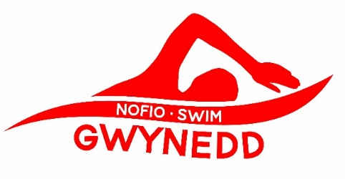

MENAI AA & B GRADE MEET

LLANDUDNO SWIM CENTRE

Sunday 8th March 2026

ENTRY FEE: £7.00 PER EVENT

CLOSING DATE FOR ENTRIES: 12th February 2026

MULTIPLE ENTRY FORM
Please enter the names of girls/boys wishing to swim in the above meet. Photocopies are acceptable, but use separate entry forms for boys/girls. Indicate the events the swimmer wishes to enter by including their current time in the correct column making sure you specify AA or B grade entered. All times must be converted to 25 m pool. The Start Rule will be used. Age on the day. See attached information sheet for cut-off times and distances.

Name | DOB | Swim Reg. No. | Age Group | Freestyle | Backstroke | Breaststroke | Butterfly | Ind Medley
Payments can be made by BACS transfer to Swim Gwynedd Performance Club
Sort code: 51 61 28
Account Number: 11358432
Please state your club name as reference

Entries to be submitted via email to swimgwyneddgala@gmail.com

Postal entries and cheques (payable to Swim Gwynedd Performance Club) can be sent to:

Ceris ap Gwilym, Cwm Eilir Isaf, Llanberis, Gwynedd LL55 4UD

Signature of Club Officer ……………………………………………………………………………………………………

Address for Correspondence ………………………………………………………………………………………………

…………………………………………………………………………………………………….. Post code …………………

Tel No ……………………………………………………….. Club (Block Capitals) ……………………………………
E-mail…………………………………………………………………………………………………………………………………



MENAI AA & B GRADE MEET – 2nd March 2025

To allow us to run this meet, clubs need to provide qualified officials who are willing to help on the day. Our requirements are one official if the club has 1-10 swimmers competing and two for 10+ swimmers in each session. Please provide their names in the form below so that we can be assured in advance that there will be sufficient support for the Referees, we will require Starters, J2’s and J1’S in each session.

Refreshments will be provided for those officials, without whom the gala cannot run.

When you submit your entry, please return the completed slip below or email it to me (swimgwyneddgala@gmail.com) at the same time.

………….………………………………………………………………………………………………………………………………………………………

Club: …………………………………………………………………………………….………………………………………………….

Name | Grade | Session 1 | Session 2 | Session 3

Please enter name, grade and tick the appropriate session box(es)

Looking forward to seeing you on the day.

Thank you for your co-operation.
Ceris ap Gwilym and the committee;
Nofio Gwynedd

